**INTRODUCTION**

* 1. **Overview**

A CRM system helps you keep your customers contact details up to date, track every interaction they have with your business, and manage their accounts. It’s designed to help you improve your customer relationships, and in turn, customer lifetime value.

A CRM is a system that helps schools manage the entire lifecycle of a potential customer sometimes also reffered to as a lead. With a CRM, you can track and store the data that’s important to your operations, all in one easy to access place.

* 1. **Purpose**

A school CRM (Customer Relationship Management), software

is a specialized tool designed to manage and track student interactions, data, and automate tasks related to student recruitment, enrollment, and retention.

**2. Problem Definition and Design Thinking:**

**2.1. EMPATHY MAP**

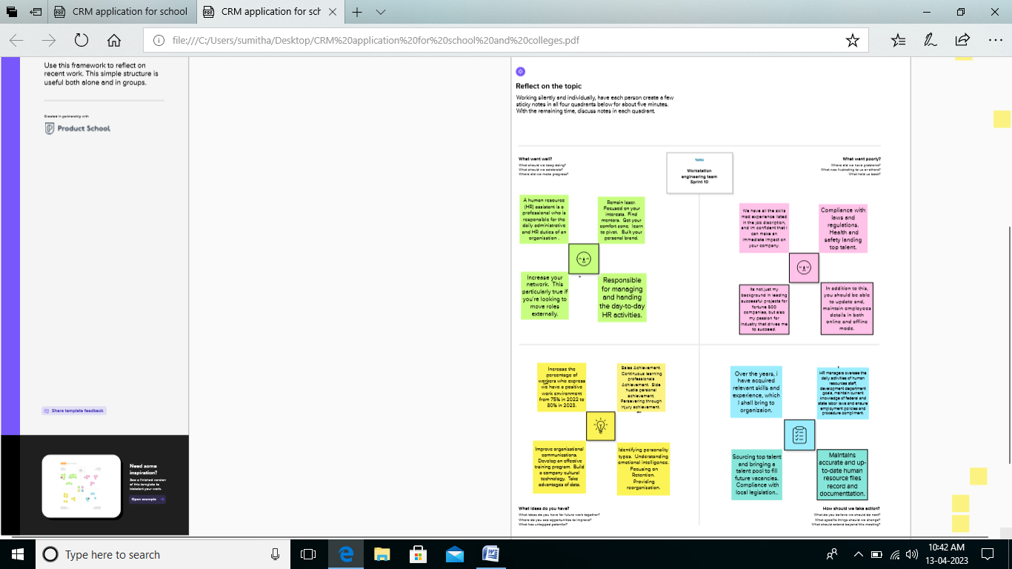

**2.2 Ideation and Brainstorming map Screenshot:**

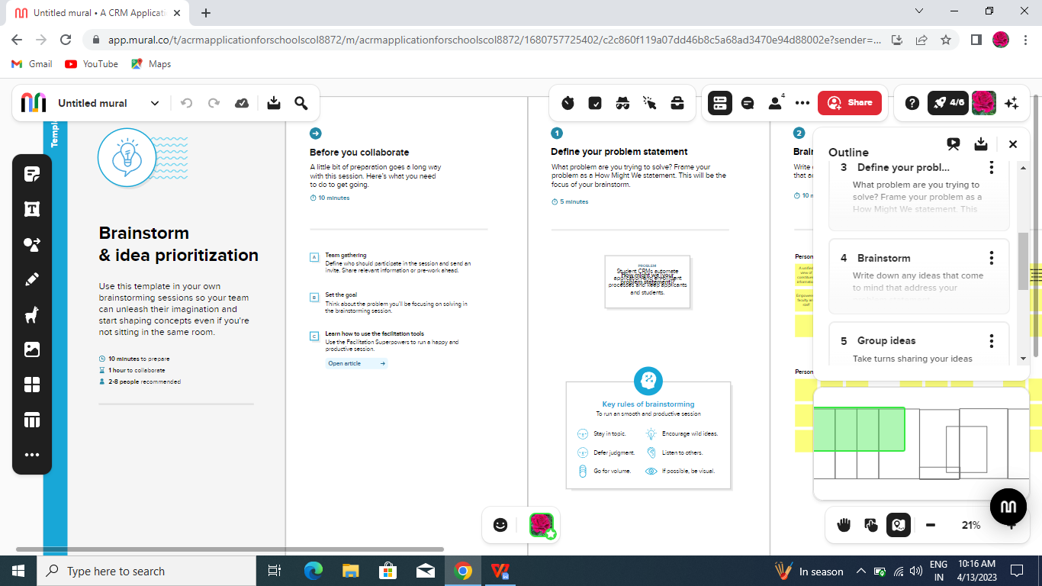

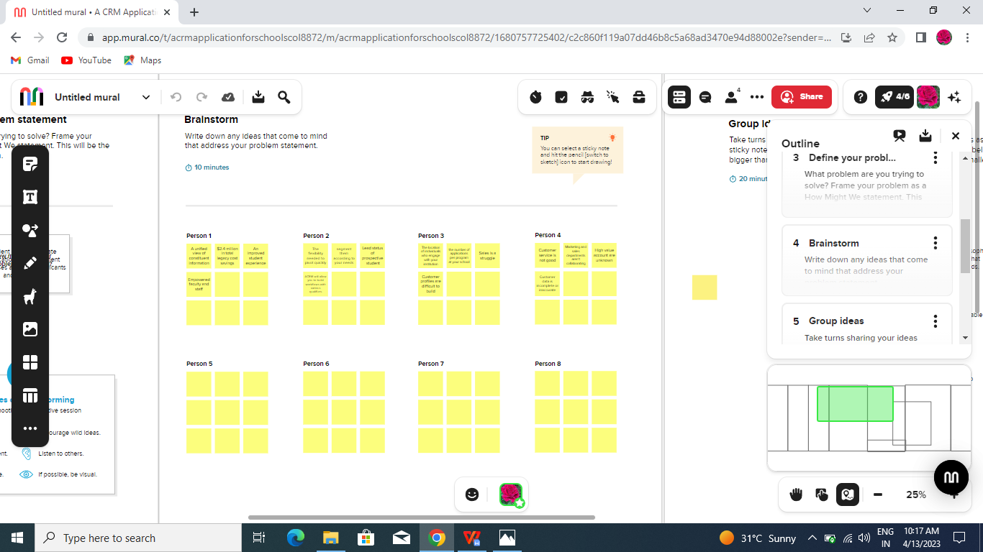

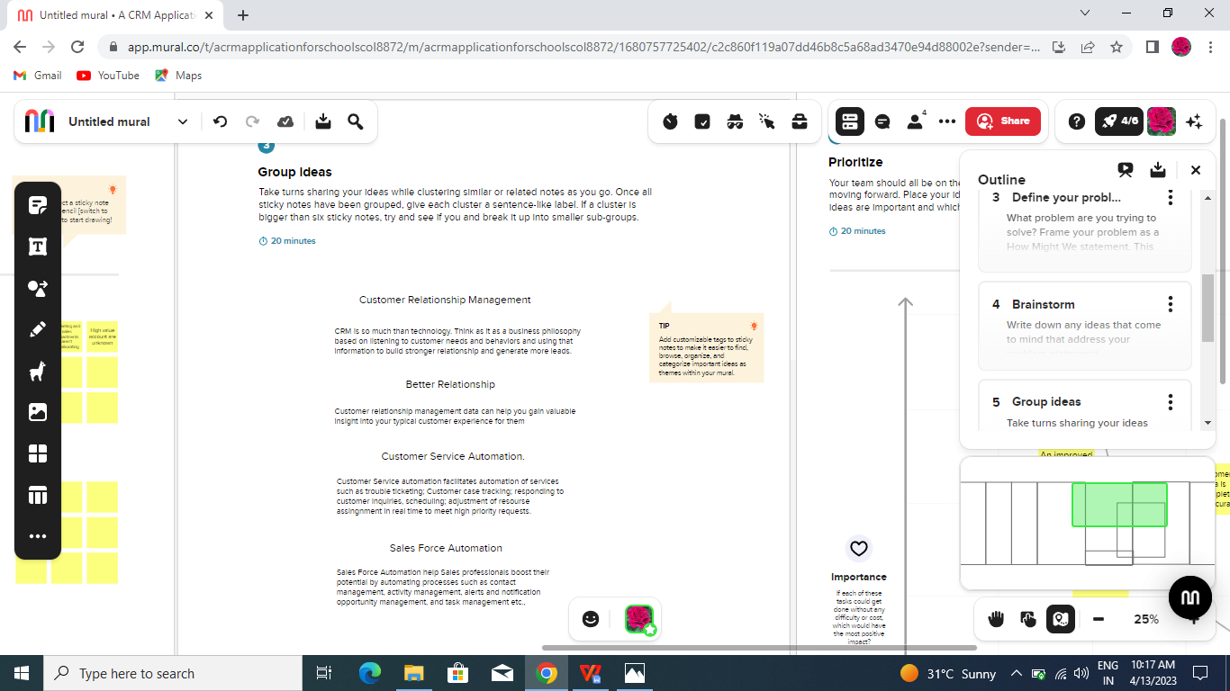

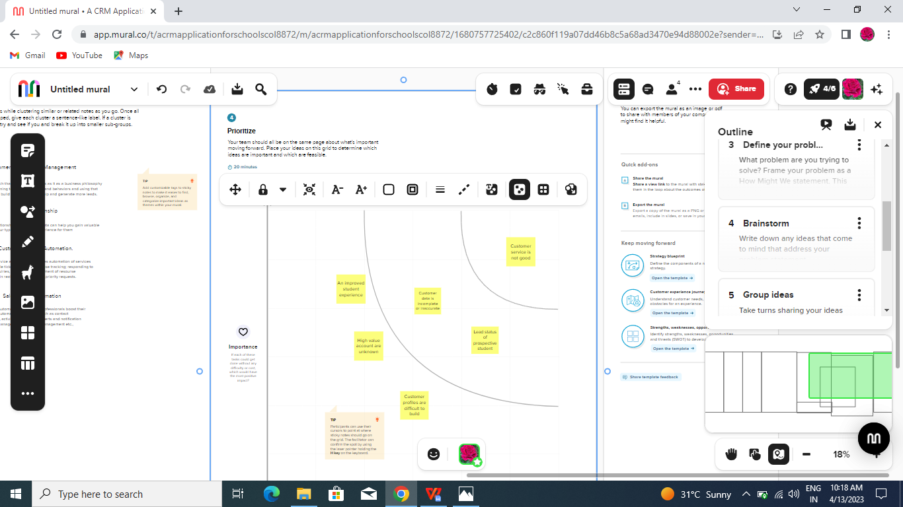

**3. RESULT:**

3.1 Data Model:

|  |  |
| --- | --- |
| Object Name | Fields in the Object |
| Object 1 | Field label: Phone number  Data type: Phone |
| Object 2 | Field label: Class  Data type: Picklist |
| Object 3 | Field label: Parent address  Data type: Text Area |

**3.2. Activity and Screenshot:**

Create salesforce Org-creating Developer Account

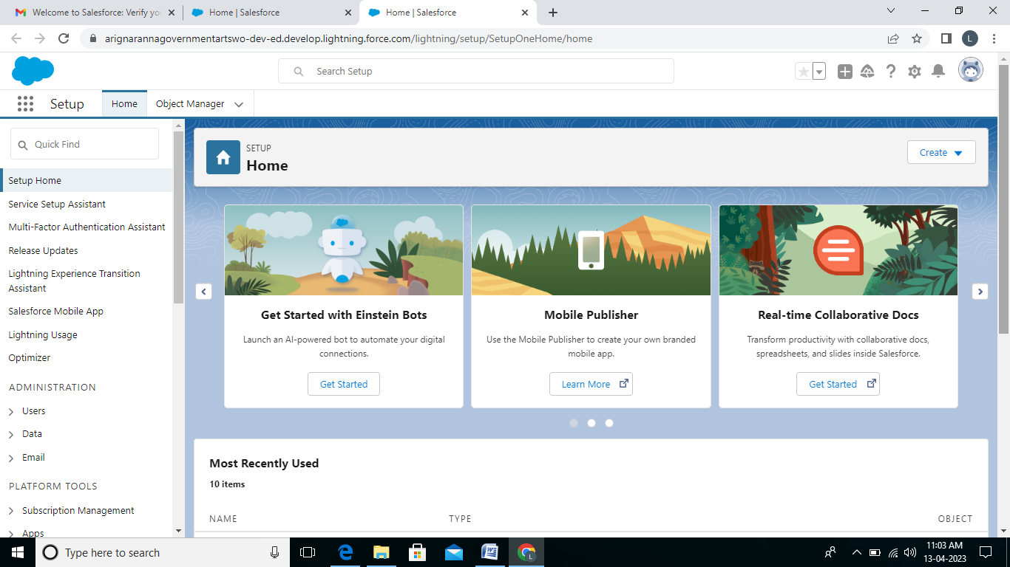

**Object:**

Creation of school object

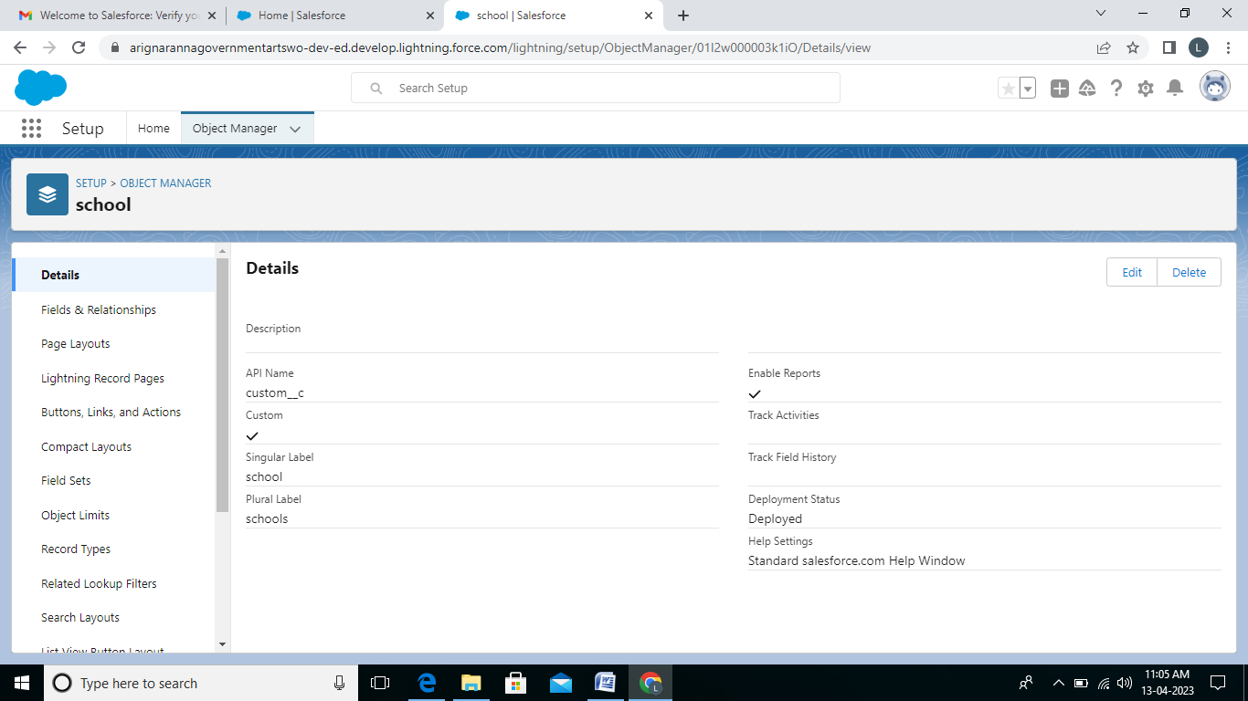

Creation of Student Object 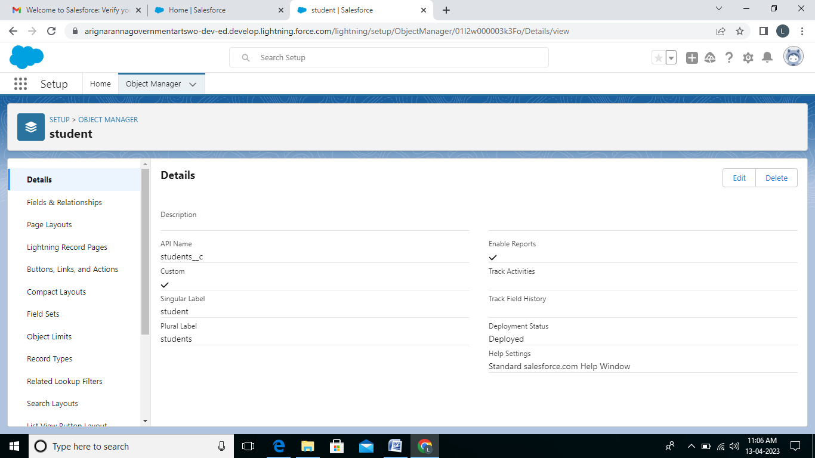

Creation of Parent Object: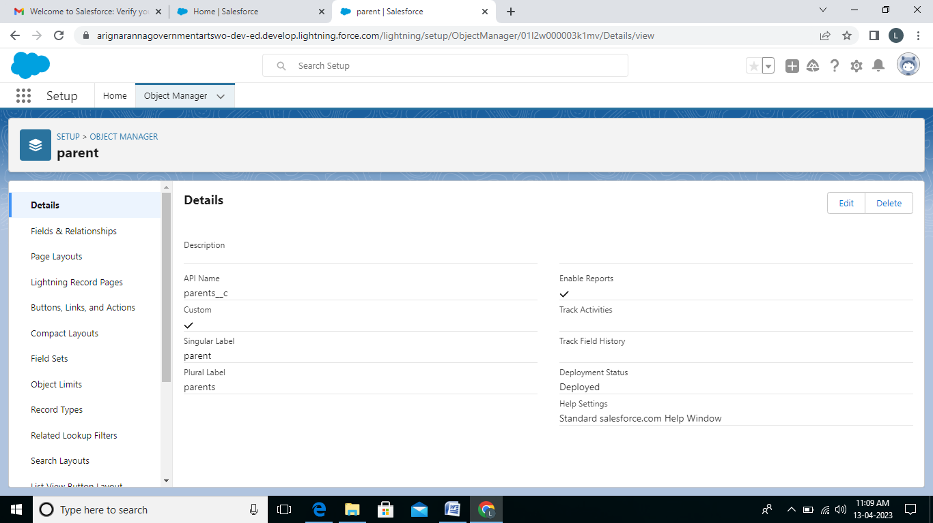

**Lighting App**

Create The School Management App

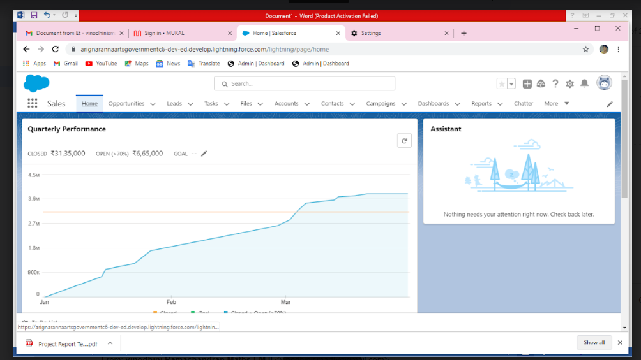

**Field and Relationship**

Creation Field for The Schools Objects

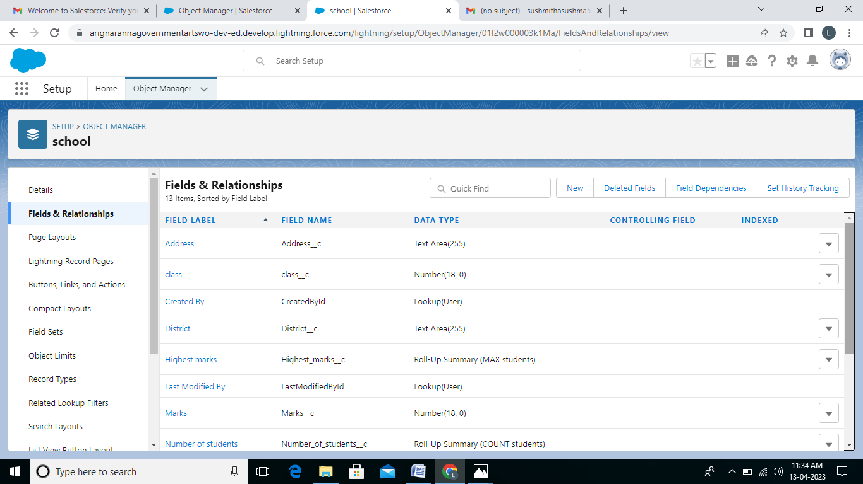

Creation of Fields for the Student Objects

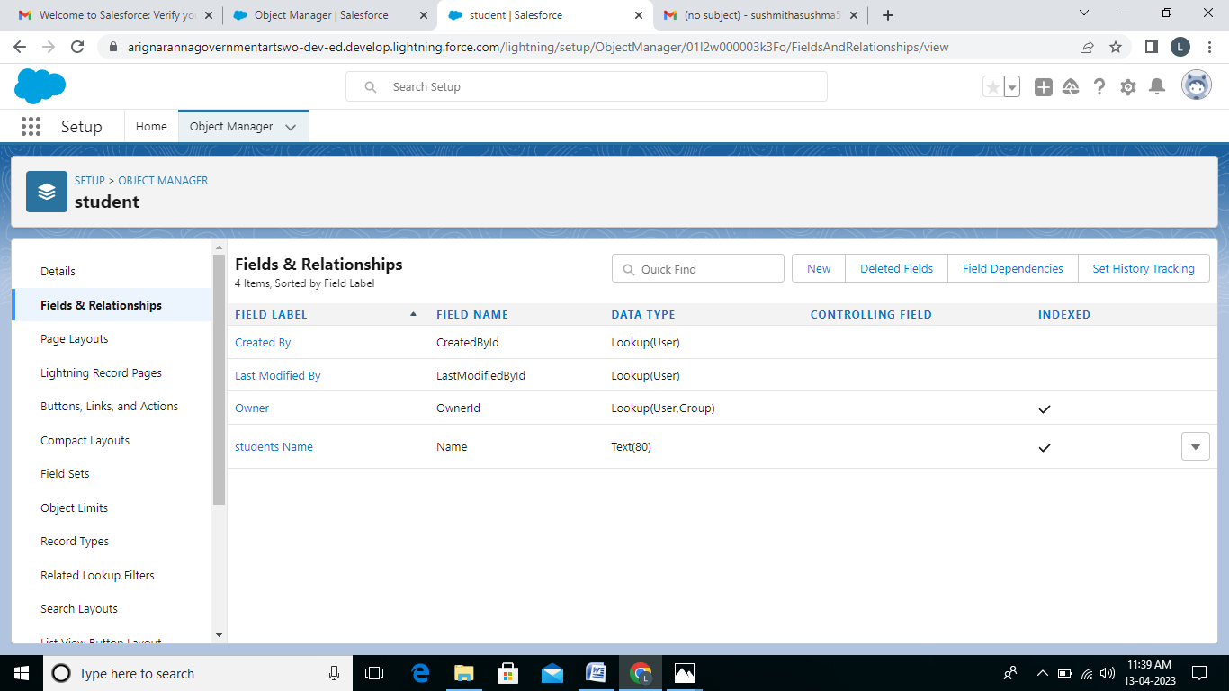

Creation of Fields for the parent objects

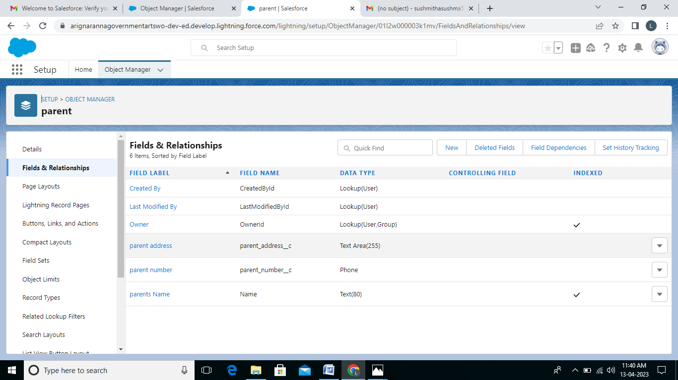

**Profile:**

Creation on Profile

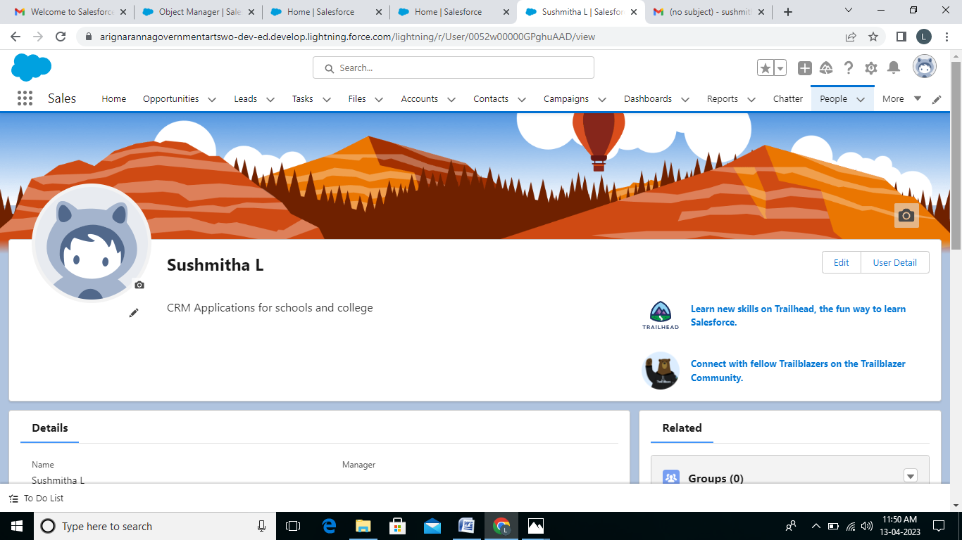

**Users**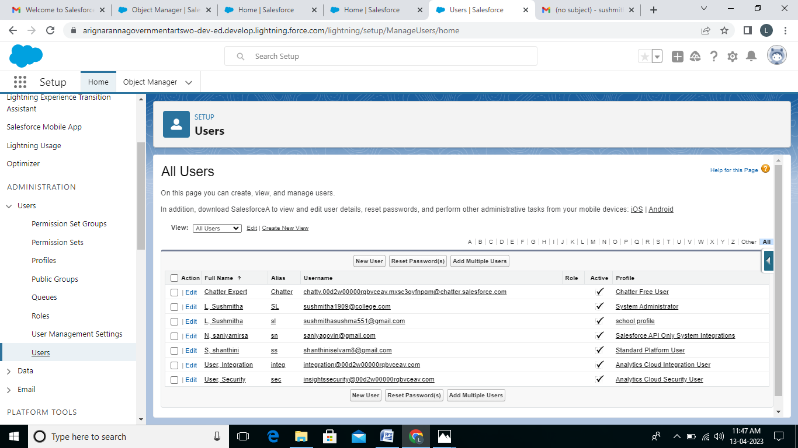

**Permission sets**

Permission 1

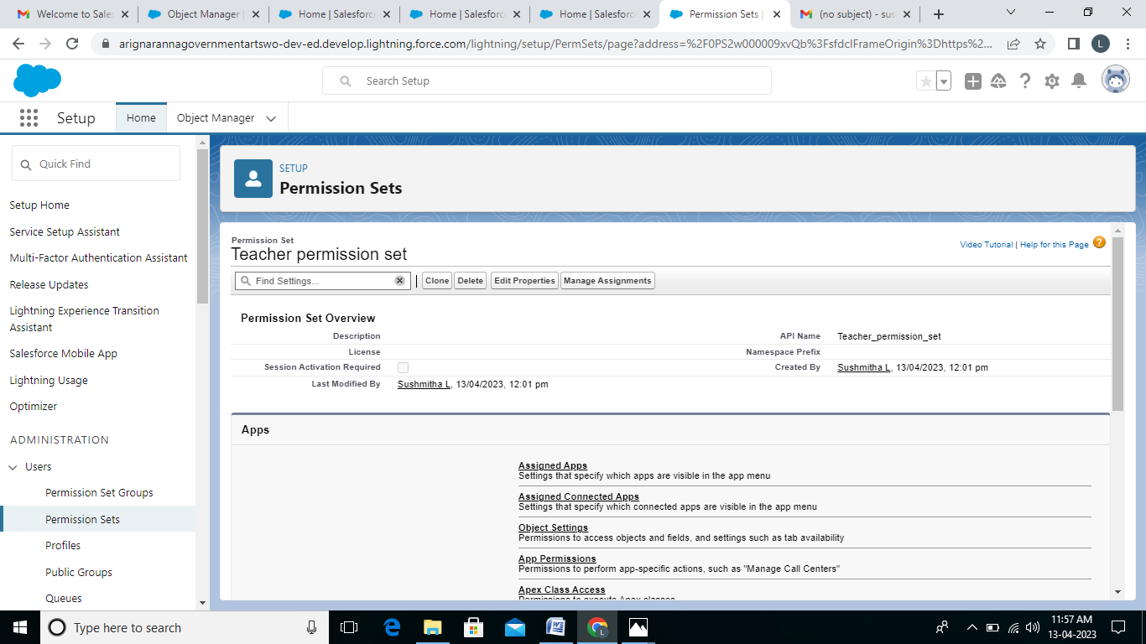

Permission 2

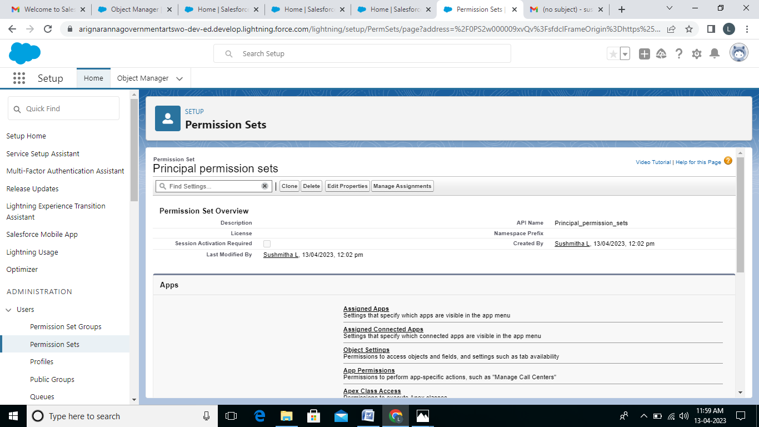

**Reports**

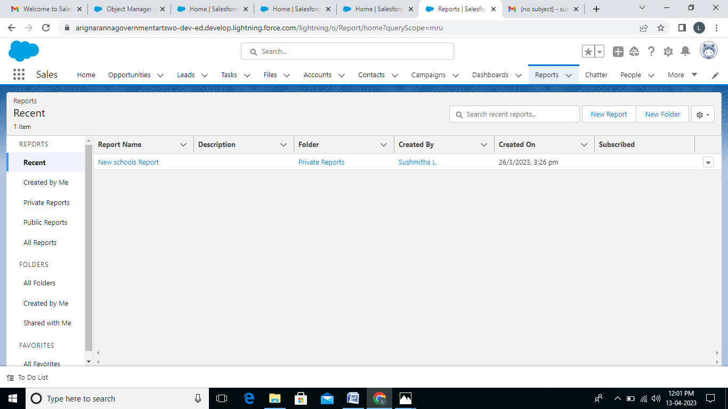

4. **Trailhead profile public URL**

Team Lead: <https://trailblazer.me/id/Isutm>

Team Member 1 <https://trailblazer.me/id/saniyamirsa2004>

Team Member 2 <https://trailblazer.me/id/savi123456>

Team Member 3 <https://traiblazer.me/id/sselvam53>

**5. ADVANTAGES AND DISADVANTAGES**

* **Beneficial for the different department or teams of the business**

Customer relationship management automation systems can benefit small and large businesses and their teams, such as marketing, sales, customer service, field service, and project service automation teams in different aspects

* **Customers are engaged across multiple channel**

There are various advantages of using a CRM system for a business as it provides the best possible customer service by improving customer service, customer retention, tracking, customer data streamlining, operations, reducing costs, and taking the business to the next level. The CRM can engage the user with its customer across multiple channel like email, social media, live chats, and phone.

* **Provide streamline operations**

A properly implemented CRM in business provides streamlined operation by automating tasks such as order fulfillment, customer contact management, and lead tracking.

* **Improve customers service**

Customer relationship service is designed to interact with customers and store their data in one place. It helps in maintaining good customers relationship and give customers

Satisfaction.

* **A costly project**

CRM software to is an expensive investment that sum business can only afford, and if they to invested it does not

Guarantee the return on investment his worth it.

* **Loss of collected information or records**

CRM (Customer relationship management) tools can be responsible for losing the customers information as some

CRM software keeps track of customers information using remote internet connection.

**APPLICATION:**

1. **Tracking customers**:

A good CRM helps you understand your market and

the needs of your customers.

1. **Collecting data for marketing:**

A CRM saves important data in extensive customer and contact list.

1. **Improving Interactions and communications**:

A goods CRM helps you maintain great customers relationship with all your clients and let them know what your products and service can do for them.

1. **Streamlining Internal sales process**

A good CRM helps you streamline your internal sales processes so that there is consistency and quality across your sales team.

1. **Planning your operations**

A good customers relationship management tool with will help you understand your current capacity and the demand customers are likely to have for product and service.

**CONCLUSION:**

The concept of customer of relationship management is evolving and is providing sample scope of many other development his and industry to take place. Over resend past

The research and practice CRM has led to many discoveries of concept and theories already discussed. The customer relationship management has now become customer experience management. The customer have now been evaluated on the basis of not just immediate profitability but all the future profits they may come with in due course by calculating there lifetime value for the organization.

**FUTURE SCOPE**

* Customer relationship management (CRM) is a sound idea or approach for strengthening customer relationship while lowering cost and increasing productivity and profitability in the workplace.
* The idea CRM system single repository for all data sources with in a company that gives on automistic real time view of client data.
* A CRM system is huge and important, but it can used by small and large business a like as the main aim is to provide effective

Service.